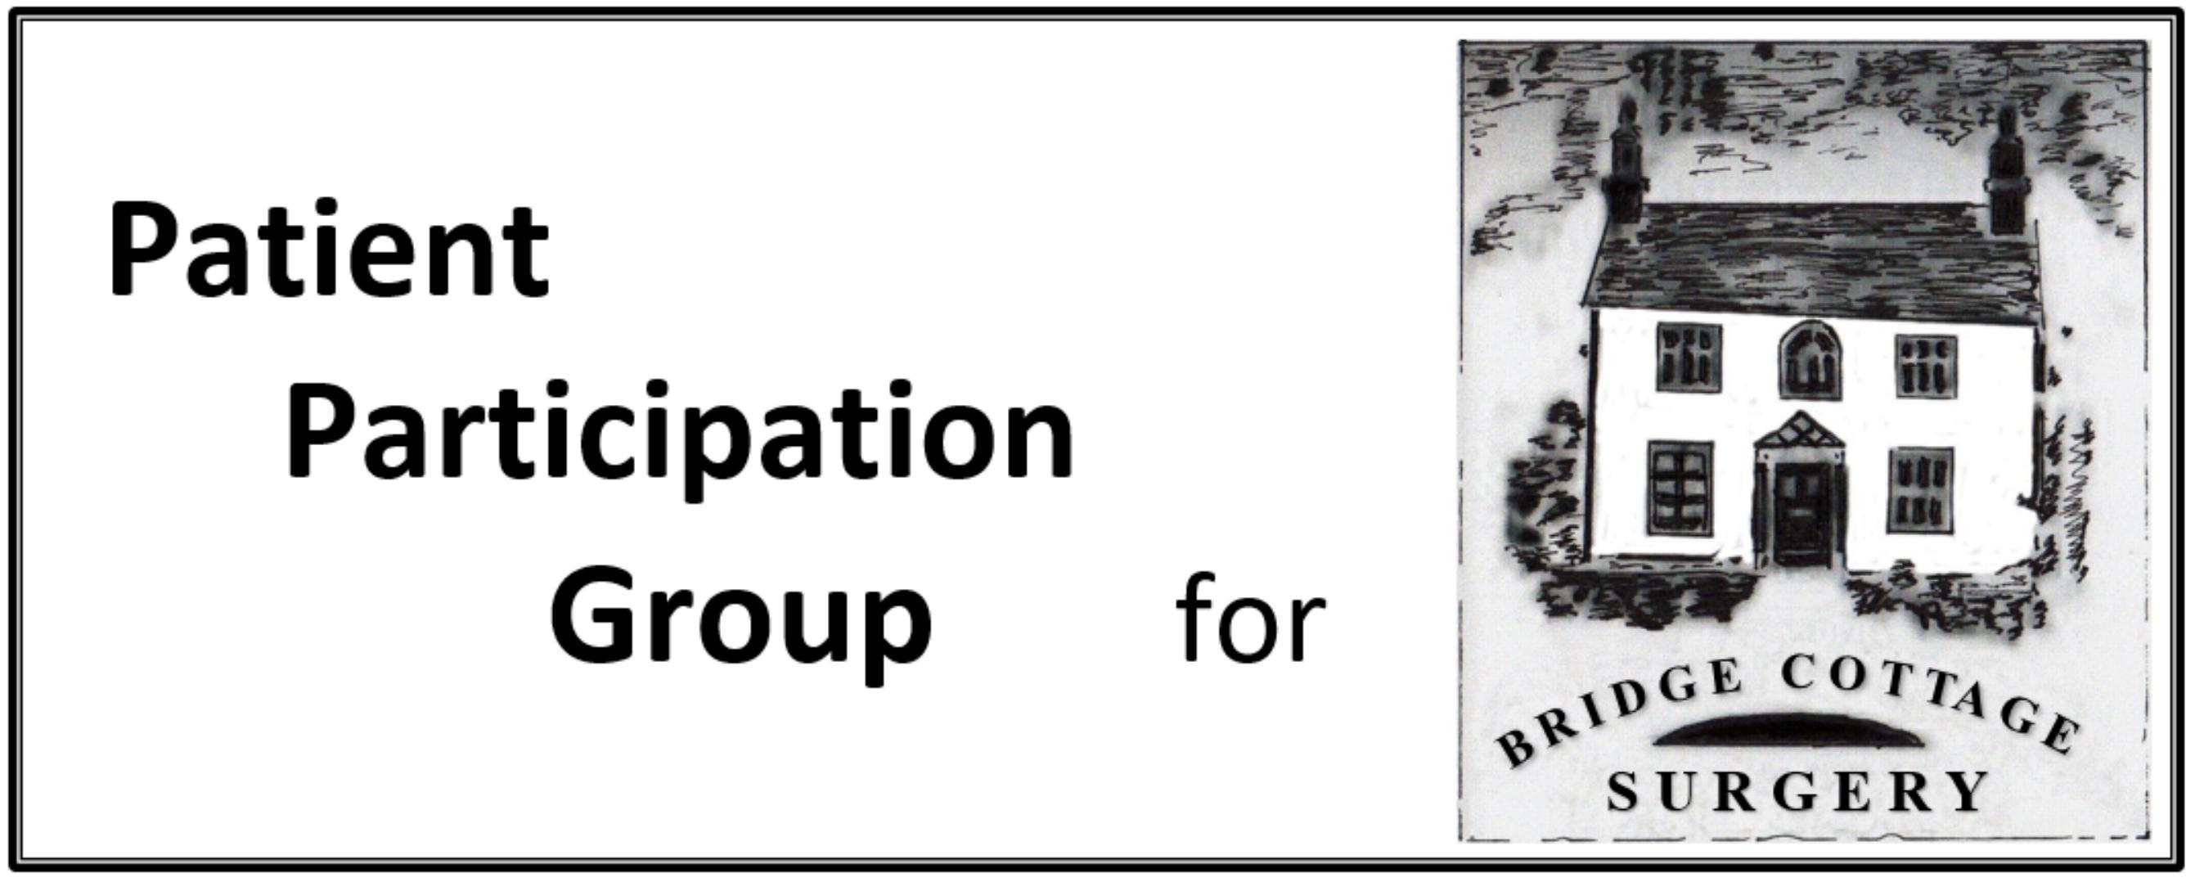

PPG Minutes

Meeting Date | 13th January 2020
Present | I Skidmore, S Otty, J Jacklin, R Aubrey, J Young, D Crossley, G. Lamb, J. Green, R. Walker  Dr Sookun was welcomed to the meeting
Apologies | L. Watson, P Bridge, Ann Gillman-Smith, L. Boon, D. Shearley, D Bell
Agenda Item | Notes | Action
Minutes | Minutes of the meeting of 18th November 2019 were approved as an accurate record.
Matter Arising | Practice Leaflet – Debbie advised that she was awaiting the final proof.  Long Term Conditions – Richard reported that the report is being finalised (shortened) and will be presented to the Executive team in February. It will then be forwarded to GP Surgeries. The main challenge is around patients with multiple long term conditions.
Patient Survey Analysis | A summary of the findings had been circulated to members. These would be discussed at the next Partners Meeting on 28th January. Thereafter the Practice is required to discuss the findings and their proposed actions with the PPG. We will discuss with them what help we can provide Appointments still remained an issue but the system would be subject to change with the introduction of e-consult.  Concerns were raised about the difficulty with which patients with Long Term Conditions could book appointment with the same doctor. Debbie reassured the group that this was possible and doctors were able to override the system to book appointments directly. | Ian/ Debbie
Cancel Out Cancer | Ian has spoken to the organisers of this. Their presentations are interactive and aimed at small groups and he was in discussions with Peter Wilson as to how best this could be rolled out to more patients. This was a possible topic for the AGM | Ian
e-consult | A presentation to the practice was planned for Tuesday. Hall Grove Surgery have been using the system for a while. The doctors have expressed some concerns about triaging patients on line rather than face to face. More information is available on the e-consult website. It was noted that this initiative would need to be implemented by April.
Communications:  Thursday Table  Magazine | January 23rd – Ian and another  27th February – Jan and Rick  26th March – volunteers required  More packs were required. Ian to check what he had.  The address for Spring House Surgery needs to be included in the pack.  Subjects to include: AAA, Sepsis, Stroke, AEII and healthwalks.  e- consult would feature in future.  February – Dementia café  March – Antibiotics  April – MS or Parkinsons  May – Awareness Week | Ian
AGM Agenda | Ian to send out Standard procedures for the meeting in advance Debbie to speak to Practice with regards to topic for the AGM of a medical nature or possibly the patient survey. Ian to do his summary of the year. | Ian  Debbie
Any Other Business | NHS England are currently reviewing the national Service Contracts for PCN’s. This is currently the subject of a consultation.  The arrangements with Peartree Surgery will remain as is until this has been agreed.  The practice are not obliged to be part of a PCN but there would be some funding implications if they were not.  It is unlikely that the practice will appoint a Social Prescriber but rather would refer to HertsHelp.. Post meeting note : it is now possible that a social prescriber resource may be available on one day of the week.  Welwyn Festival Table  Street Market is scheduled for 20th June. Ian to follow up re: booking table etc.. | Ian
Date of next meeting | 9th March 2020
Date of Annual General Meeting | 10th February 2020 at 7pm at Bridge Cottage Surgery

