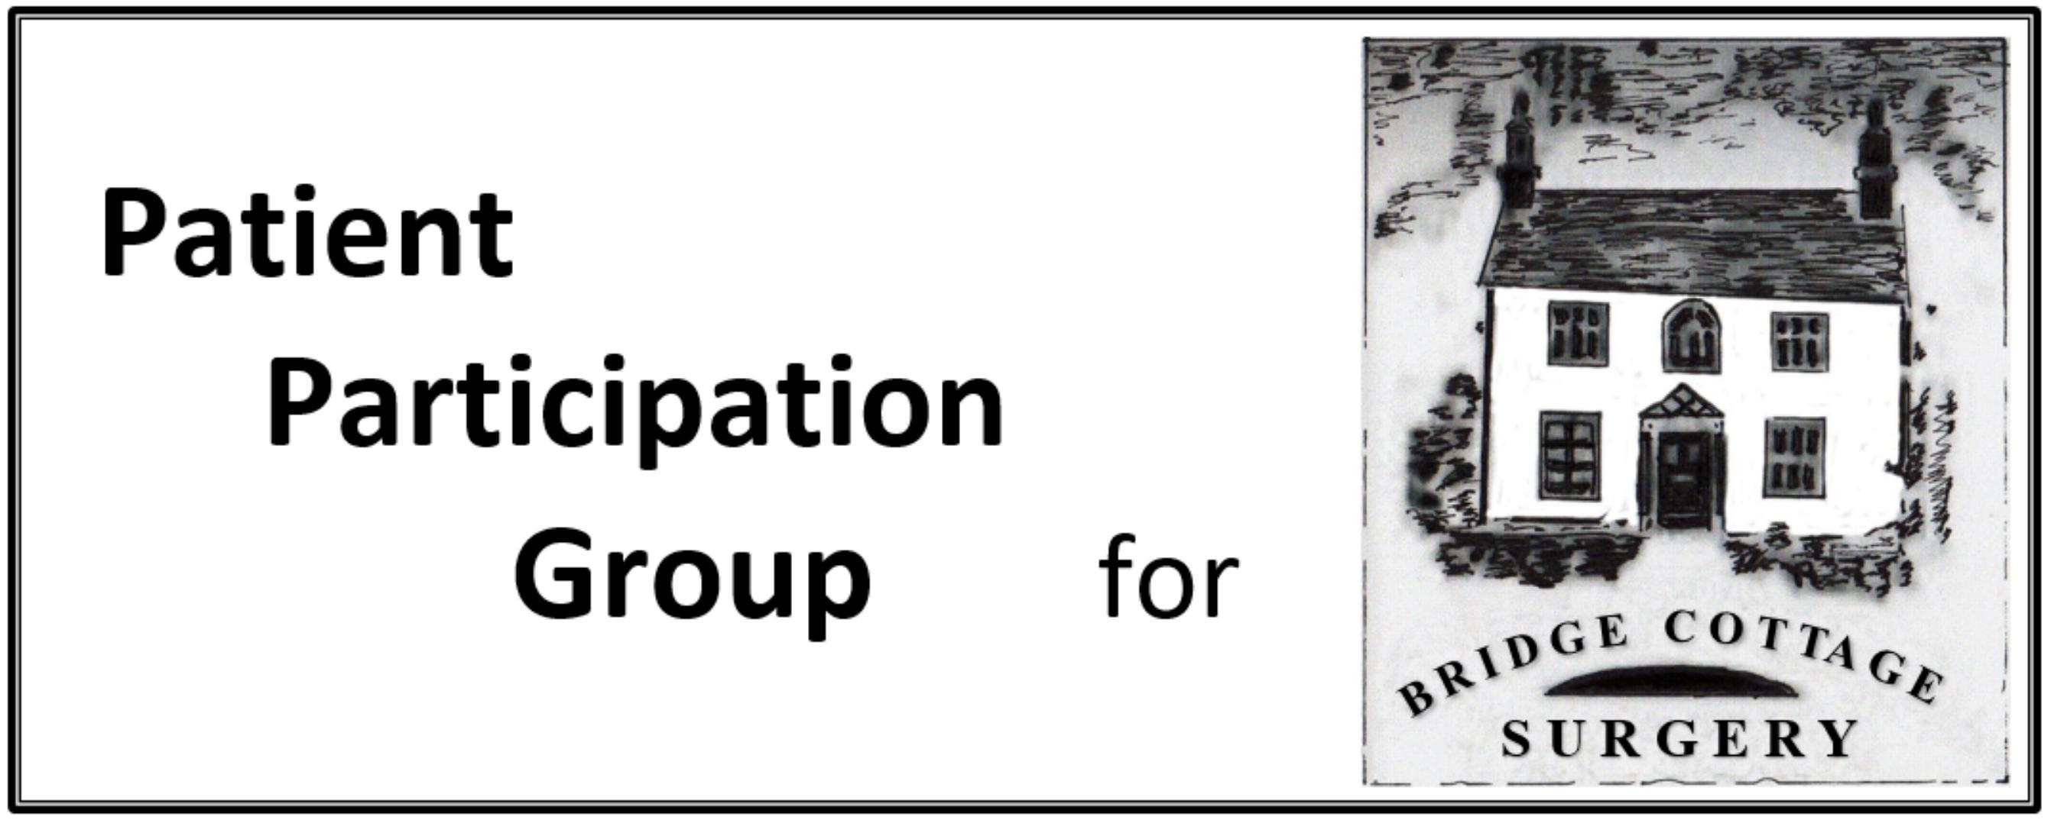

PPG Minutes

Meeting Date | 9th March 2020
Present | I Skidmore, S Otty, J Jacklin, R Aubrey, J Young, D Crossley, G. Lamb, J. Green, R. Walker, L Watson, D. Bell, J. Coates (part)
Apologies | There were none
Agenda Item | Notes | Action
Minutes | Minutes of the meeting of 13th January 2020 were approved as an accurate record and signed a such.  Jane Coates was welcomed to the group.
Matter Arising | The Welwyn Magazine. Sara reported that there had been problems in submitting the article for the March newsletter. She had submitted in good time but there had been problems at the other end. The proposed articles would be carried over till next month.  Patient Survey Details. Debbie would provide the PPG of any areas where it was felt that we could assist. Most the comments (both positive and negative) had related to booking appointments, however, with the introduction of e-consult this would change.  Practice Newletter – Debbie had previously circulated this to members and asked for any feedback. This would be available to patients attending surgery.
Coronovirus | Debbie reported that the practice had received instructions from Public Health England on Friday advising that on line bookings should be suspended and that e-consult should be used instead as this allowed for triaging of patients. Telephone bookings were still available, and all patients would be screened for the potential coronavirus risk. The practice were in the process of calling all patients who had already booked appointments on line to screen/triage them.  Debbie confirmed that the surgery has emergency stocks of protective clothing and were well prepared.  In terms of communication with regards to e-consult, there are posters in the surgery and also information on the website. Access to e-consult is via the website and she urged PPG members to familiarise themselves with the process.  It was confirmed that System One could still be used for repeat prescription requests.
AGM Update | The draft minutes had been circulated and would be added to the practice website.
Patient Locality Networks | It was reported that there are currently six groups in the East and North Herts area. The CCG are looking to consolidate these into a larger, single network. They have four meetings a year and 2 representatives from each PPG attend
Re-organisation of CCGs | It is intended that West Essex, E&N Herts and Herts Valleys will combine to form one CCG which would cover the following “general” hospitals – Watford Hospital, Lister Hospital and Princess Alexandra Hospital. Lesley gave a brief update as her role as Transition Manager and would give a further update to the PPG at a future meeting.
Primary Care Networks | The GP contract has now been clarified and simplified and is this form has been agreed. Bridge Cottage is linked to Peartree and will be known as Welwyn Garden City and Villages. The short term deliverables within the contract focused on Medication Review, Enhanced health in care homes and Early Cancer diagnosis.  It was clarified that Moors Walk surgery formed part of Peartree Surgery (see AGM minutes)  It was noted that as part of this, the practice will have access to a Social Prescriber (1 morning a week), a Clinical pharmacist (2 days) and a physiotherapist. The key role of the social prescriber was to signpost patients to other services on a face to face basis identifying what services were available to assist. This included help with PIP applications for example.
PPGs form PCNs | It was noted that the PPGs of Bridge Cottage Surgery and Peartree worked in very different ways. The aim must be to identify areas of commonality and to share best practice.
Communications:  Thursday Table  Magazine | It was agreed that in view of the Coronovirus situation, the March table would be cancelled and the April table would just consist of leaflets rather than having a physical presence.  It was agreed that the information packs should be updated to, in the first instance, remove the flow chart as this had now been superceeded. This would be updated in due course.  April – Antibiotics  May – e-consult  June – Social Prescriber
Street Market | This is due to be held on 20th June and we have currently reserved a space. Ian is able to obtain the use of a Gazebo, table and chairs and Leo Boon has offered to help in the setting up. Members were asked to send in suggestions for information to be handed out to Gill.
Any Other Business | Website – this is currently being redesigned and updated and Debbie advised that it is hoped to launch this in April  POD – it was noted that this would be discontinued although patients will still be able to take their blood pressure although the result won’t feed into the central computer system but would rather take the form of a print out. (Subject to PAT testing of the equipment)
Date of next meeting | 18th May 2020 at 10.30 was proposed.  Post meeting note: In view of the national approach to the coronavirus infection face to face meetings may not be advisable. Similarly the status of the Streetmarket is uncertain. We expect to continue to get regular updates and information from the CCG and these will be circulated as they arrive.

