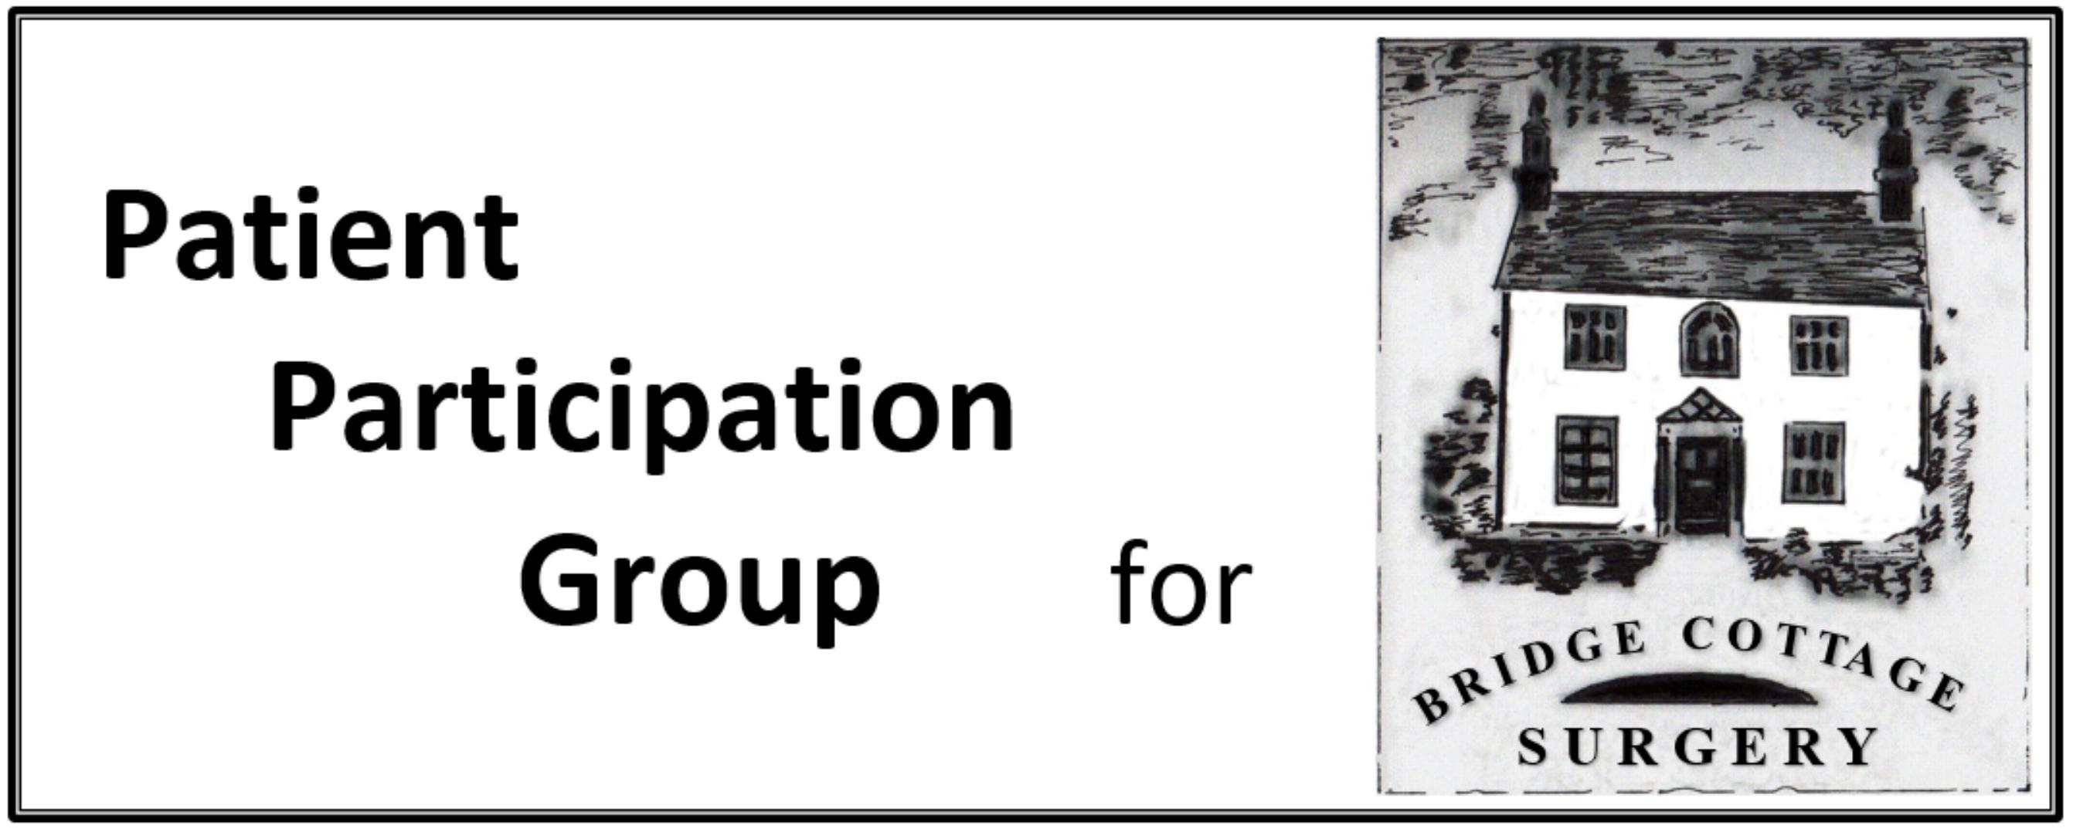

PPG AGM Minutes

Meeting Date | 11th February 2021
Present, by Zoom | I Skidmore, A Sparshott, R Aubrey, S Otty, A Batson C Clark, D Bell, J Pountney, J Collins, J Young, J Coates, D Crossley, S Maheswaran T Stevens.
Apologies | J Jacklin, L Watson
Agenda Item | Notes | Action
Resignations and Elections | Current members of the PPG, Skidmore, Otty, Aubrey, Coates, Jacklin, Watson, James, Bell: Resigned, put themselves forward for membership and were elected nem con.  I Skidmore was re-elected nem con as Chairman/Secretary. S Otty was re-elected nem con as Vice-Chair.
Minutes of the 2020 AGM | The minutes of the AGM of 10th February 2020 were approved. There were no matters arising.
Chairman’s Annual Report. | The Chairman noted the deaths of Rick Walker and Jon Green during the year. Jon was our founder and first Chairman and set the tone and ethos of the Group. Fortunately he stayed as a member after stepping down and the current chairman acknowledged the wise counsel that Jon provided.  Rick was a very active member of the group with special interest in Long Term Conditions.  We miss them both.  The PPG was not alone in finding 2020 a difficult year.  Shortly after the AGM we had our last face to face meeting (9th March) and since then have operated virtually. After a long gap we started Zoom meetings (October, November and January) and will now continue with these until Lockdown ceases. While they allow key things to be discussed they are no substitute for proper round the table discussion.  Covid prevents us from having our valuable monthly information tables in the surgery. We look forward to being able to reinstate them.  The monthly newsletters in the Parish Magazine continue and we shall be putting articles in the quarterly Parish Council Newsletter which has a wider distribution.  e-Consult was introduced shortly before Covid arrived. Some of us have used it and although it is a little clunky it works. The Practice finds that is most used over the weekend, as one might expect.  We continue to have a semi-official link with the Peartree Practice as a Primary Care Network. One of the benefits of this has been the use of the Moors Walk surgery for Covid vaccinations, which has been very efficient, and the expansion of the availability of other services.
Report from the Practice | Dr Maheswaran reported briefly on Practice activities. Covid has meant that on-line appointment booking has been suspended and all consultations start with a telephone call and triage. Face to face consultations do take place when essential. Nurse services are continuing as usual.
Objectives and Challenges for the coming year | Our numbers are depleted and we seek to add active members to the PPG.  The Practice will be carrying out a patient survey shortly. We have been asked to suggest questions for this survey.  As soon as restrictions are lifted we will start face to face meetings and our monthly information tables again.  We will consider whether to join the new NAPP community blog.
Next meeting | To be arranged – mid March

