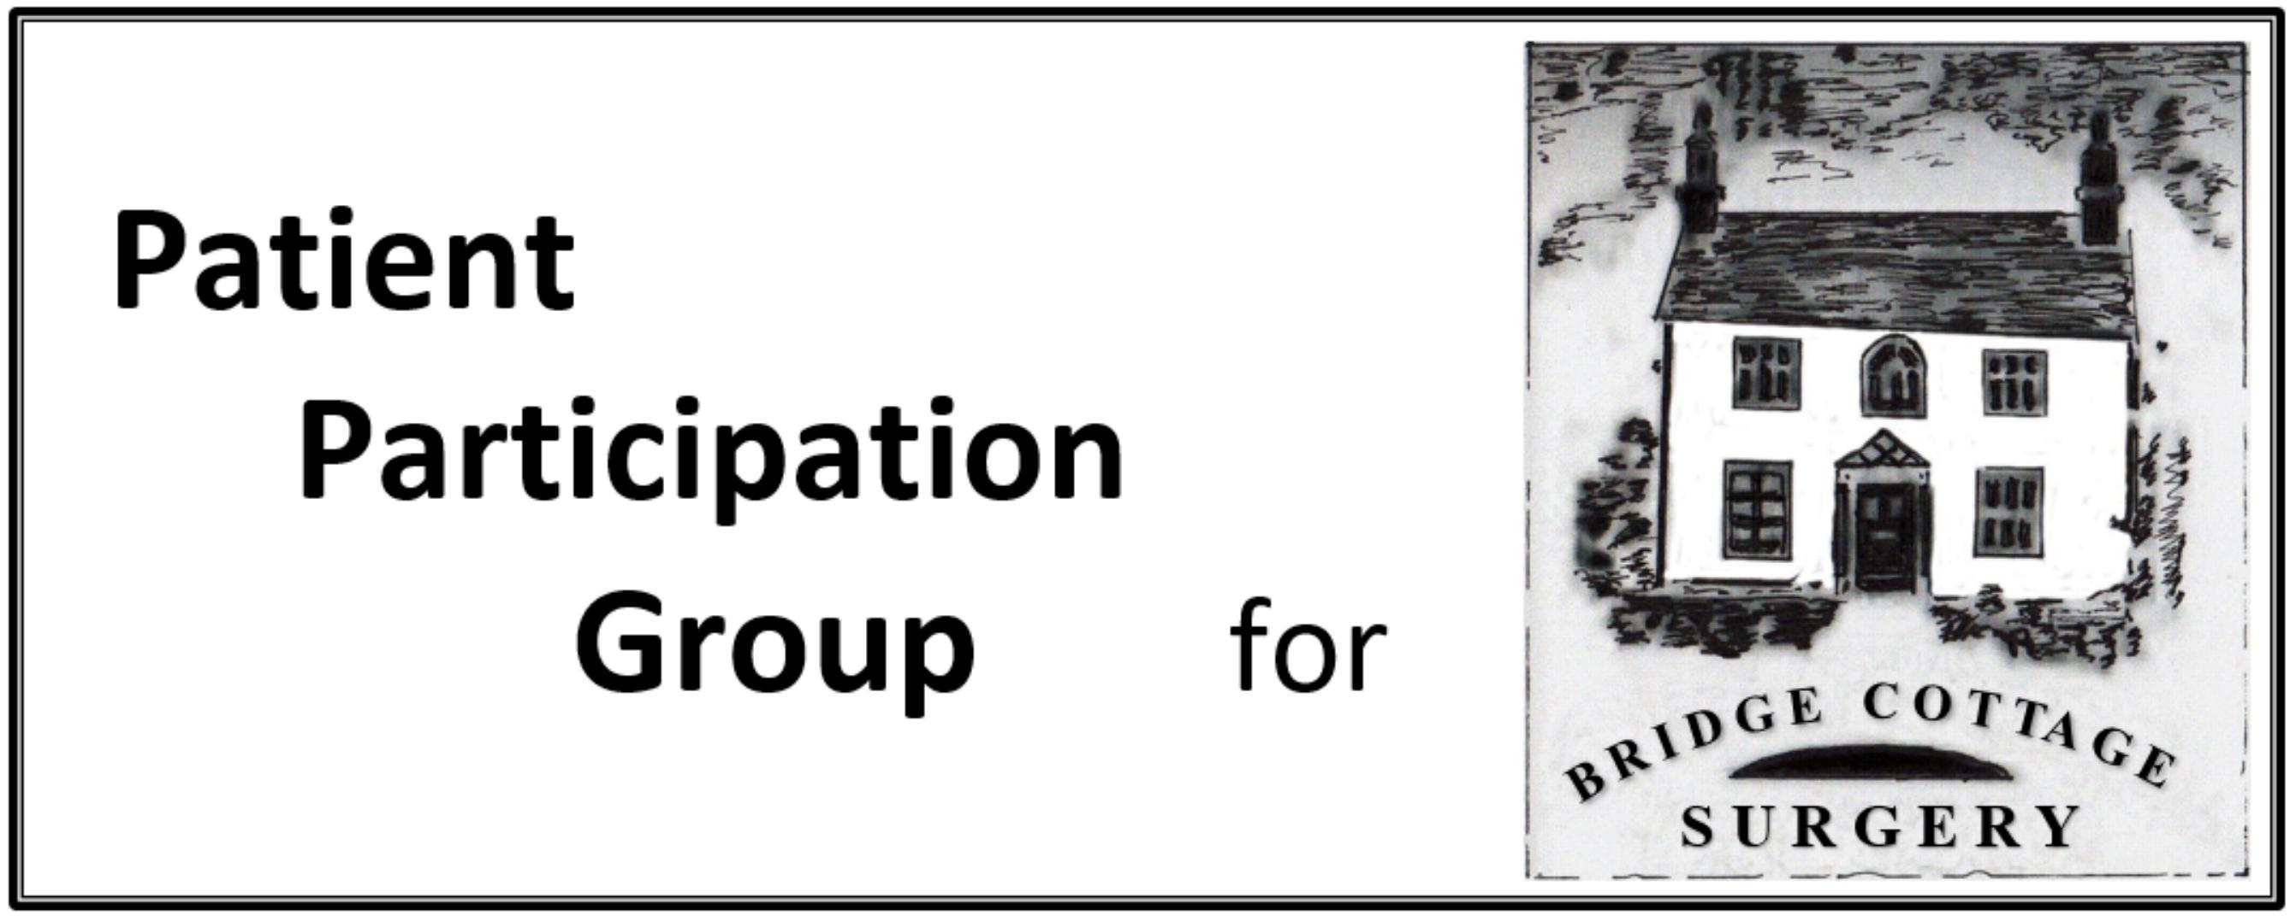

PPG AGM Minutes

Meeting Date | February 21st 2022
Present, by Zoom | D Crossley, R Aubrey, S Otty, D Bell, J Young, J Coates  J Jacklin,, I Skidmore, C Clark, T Stevens, J Pountney
Apologies | L Watson
Agenda Item | Notes | Action
Resignations and Elections | All members resigned and offered themselves for relection and were elected nem con. Clark, Stevens and Pountney were elected nem con  I Skidmore was relected Chair and Secretary  S Otty was relected Vice-Chair nem con.
Minutes of the 2021 AGM | These had been circulated and were approved as a correct record.
Chairman’s Annual Report. | My comment at this meeting last year was that we had just come through a strange year that we could not have anticipated. This year has also been strange but at least we had some idea what to expect and by the end had an indication that things might be returning if not to the old normal at least to a new one.  This time last year we were being vaccinated at Moors Walk but since then the Bridge Cottage Pharmacy has taken on this role. In some areas this burden has been carried by the local Practice but we have been fortunate to have the Pharmacy carrying the burden.  Flu vaccinations were done by the Practice and very successfully.  This time last year we were part of a PCN with Peartree in WGC, a somewhat temporary arrangement. Since then we have joined a North Herts PCN centred on Hitchin . This may seem strange as we are much closer to WGC but the indications are that it is working well. PCNs are a group of linked practices who are able to employ resources that a single Practice might find difficult or impossible.  The PPG managed five meetings in the past year, 4 by Zoom and one face to face, then Omicron came along and we were back to Zoom. We hope that we can get back to more face to face meetings.  Sara continued with the very valuable monthly Newsletters that she also circulated to other bodies.
Report from the Practice | As part of the PCN we have access to a First Point Physiotherapist, Clinical Pharmacist, Social Prescriber and currently have a Trainee Nursing Associate at the Practice. The Trainee Nursing Associate is a two year training role which is new to Practices.  The PCN have produced a PCN PPG Newsletter – copies of which are viewable on our website.  Appointments are now available to book 1, 3 and 5 days in advance, releasing at 8am for mornings and 12pm for afternoons. Online only telephone appointments are currently available to book due to the continued requirement to screen patients attending the Practice.  Infection control (face masks) remain in place in the Surgery until we are informed to the contrary by the CCG/NHS England.
Objectives and Challenges for the coming year | The first objective is to get back to face to face meetings as much as possible although daytime meetings do not work for everyone. Zoom is not good for interactive discussion but we may have to use it sometimes and we need to find out whether the occasional evening face to face meeting would work.  The information table needs to start again as soon as possible. We also need to revamp the guide to the appointments system and the complete resources that the Practice can now offer.  Behind the scenes the NHS is reorganising itself again replacing the CCGs with a larger Integrated Care System that will include both health and social care. It was due to roll out in April but now it is due in June
Date of next regular meeting

