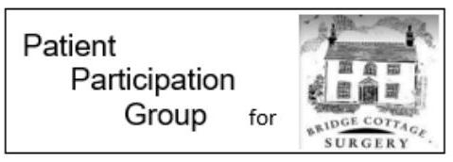
Osteoporosis
Osteoporosis is where your bones lose strength, making you more likely to break a bone than the average adult.
Losing bone strength is a normal part of ageing, but some people lose bone faster than others.
Women can lose bone strength more rapidly in the first few years after the menopause, making women more at risk of osteoporosis than men, particularly if the menopause begins early (before the age of 45) or they've had their ovaries removed.
However, osteoporosis can also affect men, younger women and children.
Other factors can also contribute to the risk of developing osteoporosis, including:
- taking high-dose steroid tablets for more than 3 months
- other medical conditions – such as inflammatory conditions, hormone-related conditions, or malabsorption problems
- a family history of osteoporosis
- long-term use of certain medicines that can affect bone strength or hormone levels, such as anti-oestrogen tablets that many women take after breast cancer
- having or having had an eating disorder such as anorexia or bulimia
- having a low body mass index (BMI)
- not exercising regularly
- heavy drinking and smoking

To help minimise the risk of developing osteoporosis, you can take steps to help keep your bones as healthy as possible. This may include:
- taking regular exercise
- healthy eating – including foods rich in calcium and vitamin D
- consider taking a daily supplement containing 10 micrograms of vitamin D – please discuss this with your pharmacist first
- making lifestyle changes – such as giving up smoking and reducing your alcohol consumption

If you are worried about osteoporosis or any of the risk factors mentioned above, please seek advice from a medical professional.
If you would like further information about the Bridge Cottage Surgery Patient Participation Group please email ppgbridgecottage@gmail.com

