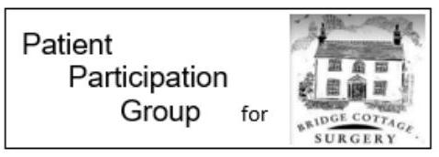
Diabetes
Diabetes is a lifelong condition that can cause a person's blood sugar level to become too high.
There are 2 main types of diabetes:
- type 1 diabetes – where the body's immune system attacks and destroys the cells that produce insulin. Type 1 diabetics use insulin to control their blood glucose
- type 2 diabetes – where the body does not produce enough insulin, or the body's cells do not react to insulin. Type 2 diabetics can improve the condition by lifestyle changes

Type 2 diabetes is far more common than type 1. In the UK, around 90% of all adults with diabetes have type 2.
During pregnancy, some women have such high levels of blood glucose that their body is unable to produce enough insulin to absorb it all. This is known as gestational diabetes.
Visit your GP as soon as possible if you experience the main symptoms of diabetes, which include:
- feeling very thirsty
- peeing more frequently than usual, particularly at night
- feeling very tired
- weight loss and loss of muscle bulk
- itching around the penis or vagina, or frequent episodes of thrush
- cuts or wounds that heal slowly
- blurred vision

Type 1 diabetes can develop quickly over weeks or even days but is often diagnosed at a young age.
Many people have type 2 diabetes for years without realising because the early symptoms tend to be mild and can be put down to other ailments.
There are no lifestyle changes you can make to lower your risk of type 1 diabetes. However, you can help manage your risk of type 2 diabetes through healthy eating, regular exercise and maintaining a healthy body weight.
For further information visit - https://www.nhs.uk/conditions/diabetes/
If you would like further information about the Bridge Cottage Surgery Patient Participation Group please email ppgbridgecottage@gmail.com

