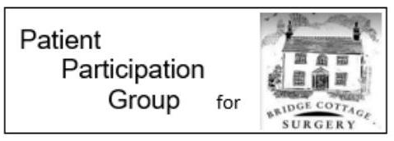
Heart Disease in Women
Women are nearly 3 times as likely to die from coronary heart disease than breast cancer. Yet it's still often thought of as a man's disease.

Heart disease refers to any condition that affects the heart including:
- heart attacks
- heart failure
- abnormal heart rhythms (arrhythmia)
- heart valve disease
- inherited or congenital heart disease

It's important that you know the signs of heart attack and other heart conditions, and when to seek medical attention.

Do
- know the symptoms of a heart attack
- get medical help immediately if you have symptoms of a heart attack
- know the symptoms of heart failure or arrythmia (abnormal heart rhythm)
- seek medical attention if you are pregnant and have chest pain or breathlessness that occurs with minimal exertion or when you are at rest
- seek medical attention if you are pregnant and have chest pain or breathlessness that comes on suddenly or is not normal for you
- talk to your healthcare professional if you have a heart condition and are planning pregnancy
- reduce your risk of heart disease by making lifestyle changes

Don't
- do not ignore symptoms of a heart attack
- do not delay getting help if you have symptoms of a heart attack

Heart attack
A heart attack is a medical emergency. It's crucial to get treatment as soon as possible.

Immediate action required: Phone 999 or go to A&E immediately if:
- you have central chest pain or discomfort in your chest that doesn't go away – it may feel like pressure, tightness or squeezing
- the pain radiates down your left arm, or both arms, or to your neck, jaw, back or stomach
- you feel sick, sweaty, lightheaded or short of breath

If you would like further information about the Bridge Cottage Surgery Patient Participation Group please email ppgbridgecottage@gmail.com

