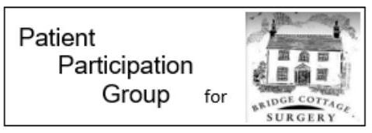
Welwyn Garden City Urgent Care Centre
Welwyn Garden City’s Urgent Care Centre (UCC) is to close overnight, due to very low numbers of patients using its services at night for a number of years. This decline has been consistent, despite an increasing local population, suggesting that people are using the new alternative sources of help and support now available.

The new closing time will be 10pm. Patients already in the UCC being treated, or waiting to be treated, at 10pm would continue to be cared for appropriately. The UCC will re-open at 8am every morning.

The Governing Body of East and North Hertfordshire Clinical Commissioning Group, which is led by local GPs, made the decision to close the UCC overnight during one of their regular online meetings in public, on Thursday 22 July.

The number of overnight visits to urgent and emergency care services in Welwyn Garden City has been low for several years, dating back to when the area was served by the Accident and Emergency department of the former QEII hospital.
In making their unanimous decision, the Governing Body noted that:
- on average, less than one person per hour visits the UCC between 10pm and 8am
- the UCC has to be staffed by at least two highly skilled nurses at all times, for safety reasons
- these staff could be better used to care for more of the area’s seriously unwell patients at the area’s Emergency Department, at the Lister Hospital in Stevenage
- a wide range of alternative sources of health help and support are available overnight locally to people with an urgent need, including overnight GP appointments and mental health help. These services have been invested in and expanded in recent years.

The proposal to close the Urgent Care Centre overnight was put to the public during an extensive 12 week public engagement campaign in 2019. Residents and stakeholders were invited to discuss the CCG’s proposals at numerous drop-in sessions and public meetings across the area, with paper and online questionnaires distributed and promoted widely.

Following this, the Governing Body voted to suspend their decision until spring 2020, to find out whether a campaign to raise awareness of the UCC and other out-of-hours services made a difference to the number of overnight visitors. The impact of the COVID-19 pandemic caused the decision to be postponed until July 2020.

The date from which the UCC will close overnight will be agreed with the Trust and publicised widely throughout the local area.

Plans will be put in place to mitigate any risk of members of the public arriving at the UCC overnight seeking treatment for minor injuries and illnesses after the unit is closed.

If you would like further information about the Bridge Cottage Surgery Patient Participation Group please email ppgbridgecottage@gmail.com.

