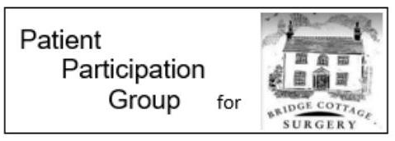
Stop in Oct!
On average, smokers live 10 years less than non-smokers. Smoking tobacco is the biggest avoidable cause of death.
Why should I stop smoking?
- You’ll live longer, feel better and have more money to spend on things and activities you like doing, like holidays.
- If you already have a lung condition, stopping smoking is the best step you can take for your health and quality of life. It will help you cope with your symptoms and stop your condition getting worse. For example, smokers are 5 times more likely to catch flu.
- It’s never too late to stop, no matter how long you have smoked for. Your lungs will work better, even if you stop when you’re over 60. If you stop smoking when you’re 30, you’re likely to live 10 years longer.
- Your friends and family will be healthier too. People who breathe in second-hand smoke are at risk of the same diseases as smokers. Second-hand smoke is particularly dangerous to babies and children as their lungs are still developing and are much more vulnerable to breathing in toxic materials.
- Stopping is a key way to protect your children’s health in the long term. Children are much more likely to take up smoking if their parents smoke.
British Lung Foundation's top tips for stopping smoking:
- Pick a date to stop and decide you’ll be a non-smoker from that day. Tell your family and friends and plan something fun to take your mind off it.
- Ask your friends and family for support. If someone close to you is thinking of stopping, why not stop at the same time so you can support each other?
- Get rid of everything in your home or at work that reminds you of smoking.
- Call yourself a non-smoker and think of yourself as one.
- Think about the possible withdrawal symptoms and how you will cope.
For further advice and support with quitting, speak to your community pharmacist or call 0800 389 3998 or text SMOKEFREE to 80818 to access local stop smoking clinics.
If you would like further information about the Bridge Cottage Surgery Patient Participation Group please email ppgbridgecottage@gmail.com
Information from www.blf.org.uk

