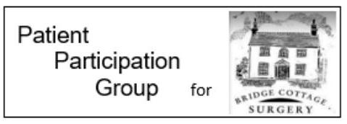
Hay Fever
Hayfever is a common allergic condition that affects 1 in 5 people at some point in their lives. You can have an allergy to:
- tree pollen, released during the spring
- grass pollen, released late spring/early summer
- weed pollen, released late autumn
- other pollen ie conifer pollen which may be released after the traditional hay fever season.

Symptoms of hay fever include:
- Sneezing and coughing
- A runny or blocked nose
- Itchy, red or watery eyes
- Itchy throat, mouth, nose and ears
- Loss of smell
- Headache and/or earache
- Feeling tired

Unfortunately there is no cure for hay fever but you can do a few things to ease symptoms:
- put Vaseline around your nostrils to trap pollen
- wear wraparound sunglasses to stop pollen getting into your eyes
- shower and change your clothes after you've been outside to wash pollen off
- stay indoors whenever possible
- keep windows and doors shut as much as possible
- vacuum regularly and dust with a damp cloth
- buy a pollen filter for the air vents in your car and a vacuum cleaner with a special HEPA filter
But:
- do not cut grass or walk on grass
- do not spend too much time outside
- do not keep fresh flowers in the house
- do not smoke or be around smoke – it makes your symptoms worse
- do not dry clothes outside – they can catch pollen
- do not let pets into the house if possible – they can carry pollen indoors

Speak to your pharmacist if you have hay fever. They can give advice and suggest the best treatments, like antihistamine drops, tablets or nasal sprays.
If you would like further information about the Bridge Cottage Surgery Patient Participation Group please email ppgbridgecottage@gmail.com
Information taken from – www.nhs.uk

